Batch-(2020-6289)



**Automation testing on Meesho Website using TestNG**

By

**Shreya Dhanvij**

Batch- (2020-6289)

Under the Guidance of,

**Priyanka Desle (Technical Trainer)**

EduBridge

Introduction

This Project aims to do overall testing like functional testing, GUI testing on website to check quality of application. It saves time for manually doing this testing. It helps to improve quality of website. In this project our main focus is to check functionalities available on website. Also it includes title check of the website.

Software Requirements

Operating system :- Window 10

Browser: - Latest version of Google Chrome

IDE: - Eclipse IDE

Front- End :- Java 1.8 & TestNG

**BeforeMethod-To Launch Browser and open the Meesho Website**

System.setProperty ("webdriver. chrome. driver", "C:\\Users\\Shreya\\OneDrive\\Desktop\\Selenium JAR\\chromedriver.exe");

WebDriver w=new ChromeDriver();

w.get("https://meesho.com/");

**TC01- To check the URL and Title of Meesho Website**

String URL=w.getCurrentUrl();

System.out.println(URL);

String Title=w.getTitle();

System.out.println(Title);

**TC02-To test the functionality of Register Page**

Actions a=new Actions(w);

WebElement Profile= w.findElement(By.xpath("//*[text()=\"Profile\"]"));

a. moveToElement (Profile). build (). perform ();

WebElement signup=w. findElement (By. xpath("//*[text()=\"Sign Up\"]"));

signup.click();

WebElement O=w.findElement(By.xpath("//input[@type='tel']"));

O. sendKeys ("9028367857”) ; //with valid data

//click on "send OTP"

w. findElement (By. xpath ("//span [contains (text (),'Send OTP')]")). click ();

a. moveToElement (Profile). build (). perform ();

WebElement P=w.findElement(By. xpath("//*[@id=\"__next\"]/div [2]/div [1]

/div/div [3]/div [5]/div/div/div [1]/div/div [2]/span [1]"));

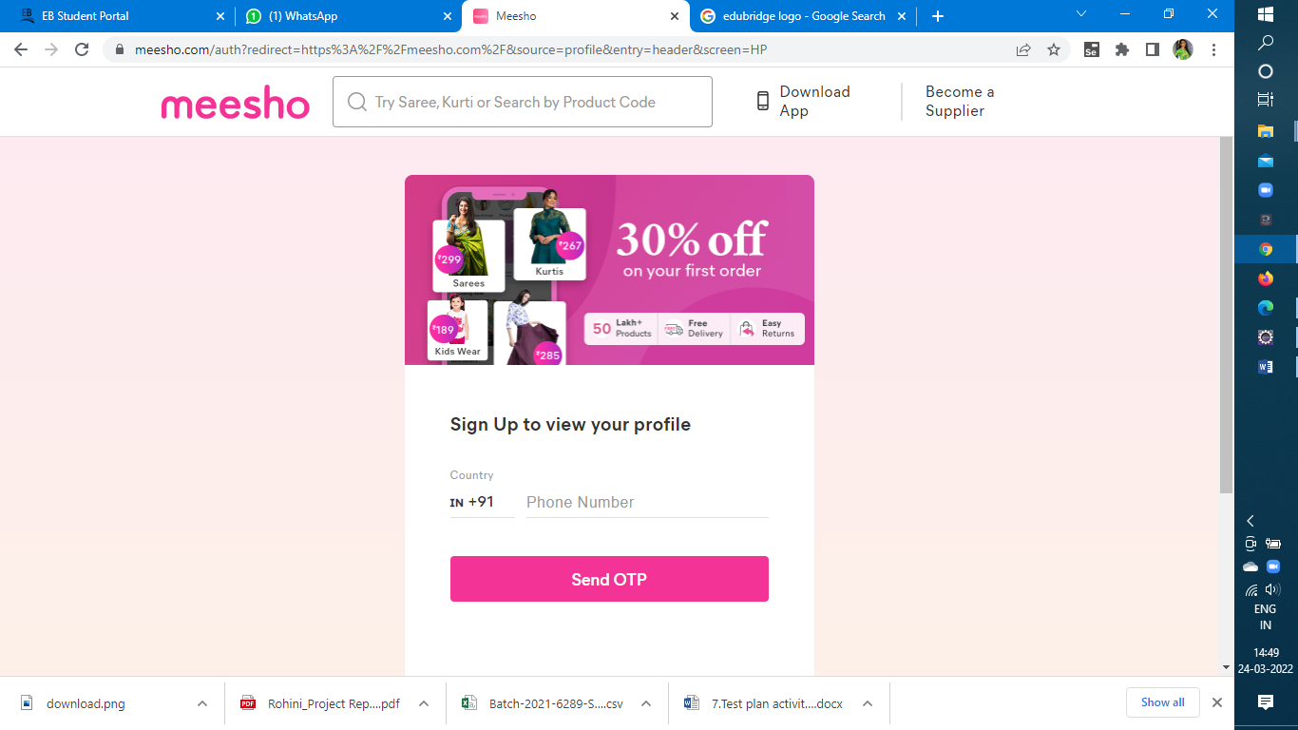

**TC05: To check become a supplier function**

WebElement Supplier=w.findElement(By. xpath("//*[@id=\"__next\"]/div

[2]/div[1]/div/div[3]/div[3]/span"));

Supplier. Click ();

**TC06: To check search Bar and add that searched product in cart**

WebElement Searchbar=w.findElement(By. xpath("//body/div[@id='__next']

/div[2]/div[1]/div[1]/div[2]/div[1]/input[1]"));

Searchbar.sendKeys("Saree");

WebElement Search=w.findElement(By. xpath("//body/div[@id='__next']/div [2]

/div [1]/div [1]/div [2]/div [1]/input [1]"));

Search.sendKeys(Keys. ENTER);

**TC07: Add To Cart Searched Product**

WebElement Add=w.findElement(By. xpath("//*[@id=\"__next\"]/div [3]/div

/div [1]/div/div [2]/div [2]"));

Add. Click ();

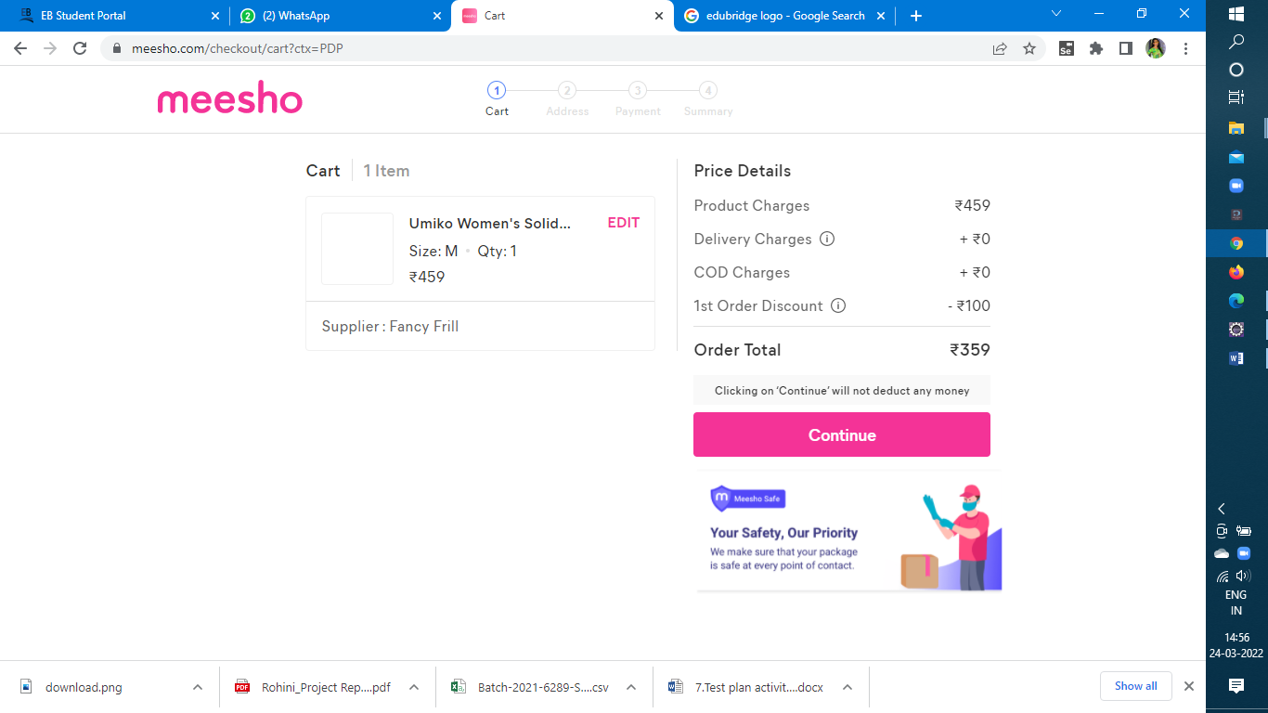

**TC08: To check remove from cart function**

WebElement Cart=w.findElement(By. xpath("//*[@id=\"__next\"]/div[2]

/div[1]/div/div[3]/div[6]/span"));

Cart. Click ();

WebElement Edit=w.findElement(By. xpath("//*[@id=\"__next\"]/div [3]

/div/div/div[1]/div[2]/div[1]/div[2]/div[1]/div"));

Edit. Click ();

WebElement Remove=w.findElement(By. xpath ("/html/body/div [2]/div [2]/div/

div[2]/div[1]/div/div[2]/div[1]/div/button/div/span"));

Remove. Click ();

**TC09: To check women ethnic section**

//Mouse over Women ethnic section

Actions a=new Actions(w);

WebElement WE=w.findElement(By. xpath("//*[@id=\"__next\"]/div [2]/

div[3]/div/div[1]/span"));

a. moveToElement(WE). build (). perform ();

//Click on georgette sarees

WebElement Georgette=w.findElement(By. xpath("//*[@id=\"__next\"]

/div[2]/div[3]/div/div[2]/div/div[2]/a[5]/p"));

Georgette. Click ();

//click on any result

WebElement img1=w.findElement(By. xpath("//*[@id=\"__next\"]/div [3]/

div[1]/div/div/div[4]/div/div[1]/a"));

img1.click();

//Click on more information about product

WebElement info=w. findElement (By. xpath("//*[@id=\"__next\"]/div[3]/

div/div[2]/div[3]/div/span"));

info. Click ();

w. findElement (By. xpath ("//*[@class='Icon-sc-1iwi4w1-0 iRATWY']")). click ();

//Click on view shop

WebElement ViewShop=w.findElement(By. xpath("//*[@id=\"__next\"]/

div[3]/div/div[2]/div[4]/div/div[1]/div[2]/button"));

ViewShop.click();

**TC10: To check Next button in result page**

//click on next

WebElement next=w. findElement (By. xpath ("//span [contains (text (),

'NEXT')]"));

next. Click ();

**TC11: To check Careers button**

WebElement career=w. findElement (By. linkText("Careers"));

career. Click ();

**TC12: To check FB link button**

//click on FB link

WebElement F=w.findElement(By. xpath("//*[@id=\"__next\"]/div [4]/

div[1]/div/div[4]/div/div[1]/div/a[1]/div"));

F.click();

**TC13: To check Legal and policies button**

WebElementL P=w.findElement(By. xpath("//*[@id=\"__next\"]/div [4]/

div[1]/div/div[3]/div[1]/a"));

LP. click ();

**TestNG.xml**

<?xml version=*"1.0"* encoding=*"UTF-8"*?>

<!DOCTYPE suite SYSTEM "https://testng.org/testng-1.0.dtd">

<suite name=*"Suite"*>

<test thread-count=*"5"* name=*"Test"*>

<classes>

<class name=*"MeeshoTestNG.TC01URLTitle"*/>

<class name=*"MeeshoTestNG.TC02Registration"*/>

<class name=*"MeeshoTestNG.TC03BecomeASupplier"*/>

<class name=*"MeeshoTestNG.TC05WomenEthenicModule"*/>

<class name=*"MeeshoTestNG.TC06WomenWesternModule"*/>

<class name=*"MeeshoTestNG.TC07JewelleryNAccessories"*/>

<class name=*"MeeshoTestNG.TC08Men"*/>

<class name=*"MeeshoTestNG.TC09BeautynHealth"*/>

<class name=*"MeeshoTestNG.TC10BagsnFootwear"*/>

<class name=*"MeeshoTestNG.TC11HomeNKitchen"*/>

<class name=*"MeeshoTestNG.TC12Electronics"*/>

<class name=*"MeeshoTestNG.TC13NextButton"*/>

<class name=*"MeeshoTestNG.TC14ViewAll"*/>

<class name=*"MeeshoTestNG.TC15Careers"*/>

<class name=*"MeeshoTestNG.TC16Facebook"*/>

<class name=*"MeeshoTestNG.TC17InstaGram"*/>

<class name=*"MeeshoTestNG.TC18YouTube"*/>

<class name=*"MeeshoTestNG.TC19LinkedIn"*/>

<class name=*"MeeshoTestNG.TC20download"*/>

<class name=*"MeeshoTestNG.TC21LEGAL"*/>

<class name=*"MeeshoTestNG.TC22Gplay"*/>

</classes>

</test> <!-- Test -->

</suite> <!-- Suite -->

---------------------------------------------------------END---------------------------------------------------------